**U.S. LOCKDOWN due to COVID-19 impact**

**CSE 2016118274, HyunWook, Hong**

The emergence of a new type of corona virus (COVID-19) and infectious disease that have spread outside China is causing damage to many people in the world beyond the landing of Republic of Korea and Italy. ‘The Pandemic’ was declared by the World Health Organization on March 11, and as of April 1, the country with the largest number of confirmed persons in the world has about 190,000 cases, and the figure ranks as the United States in figure 1.

President Donald Trump, who dismissed COVID-19 as the flu, has now declared lockdown in response to expert opinion.

There are two main reasons for the skyrocketing figure in Europe, including the United States:

1. When the initial COVID-19 occurred, only planes from Wuhan, Hubei in China were banned, and because of the crack, those who entered via other regions failed to complete perfect quarantine. As a result, the people became virus carriers in other countries.
2. It is due to the culture of people in western countries not wearing masks, greeting culture such as kissing, and light awareness of the corona virus. Even at this moment when the entrants skyrocketed, there are many people who did not wear masks, and Sweden has an ironic policy for everyone to get autoimmunity.

*Additionally, in the U.S., there is a social notion that wearing a mask or hooded hat is a criminal outfit.

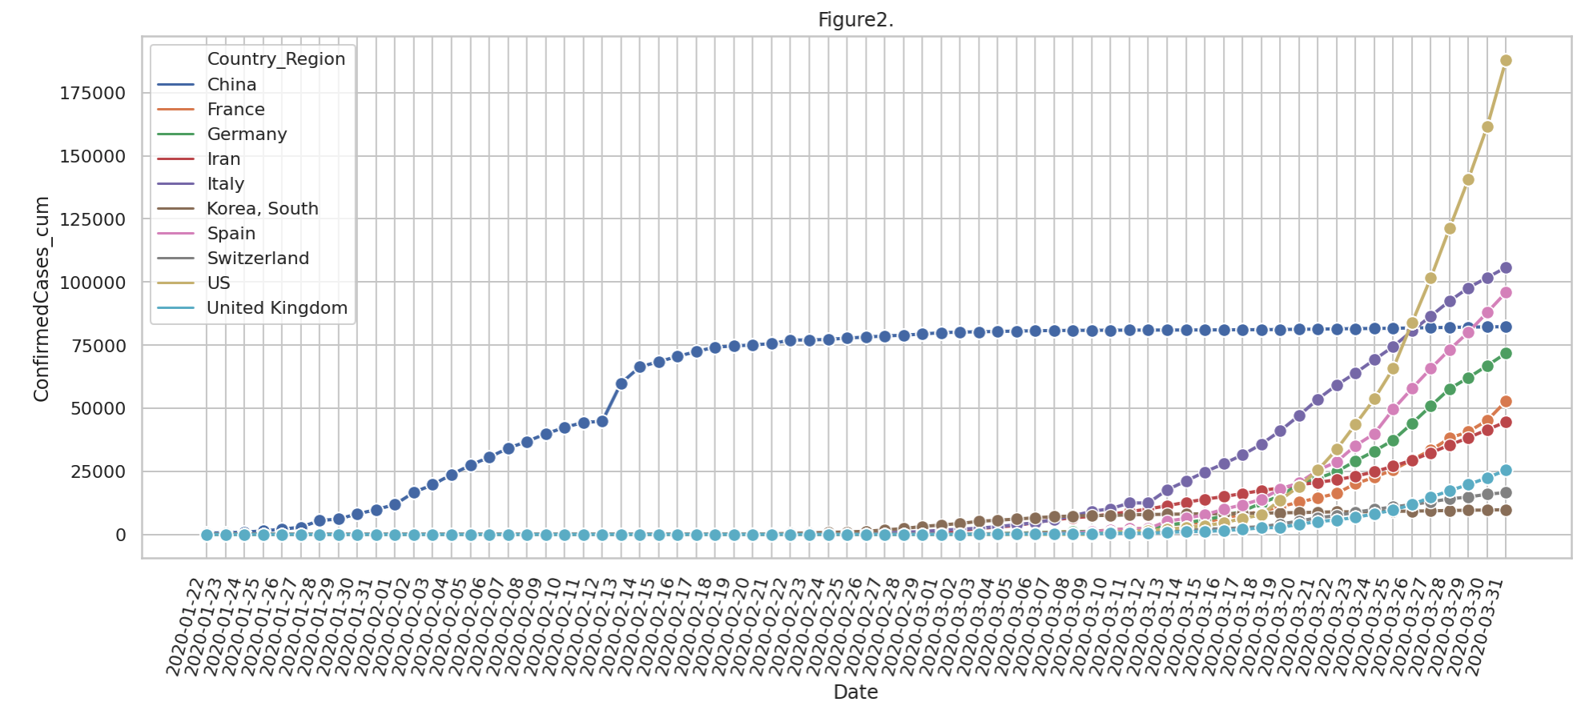

Among them, it is also analyzed that the reason that the U.S. is currently skyrocketing is that it has greatly strengthened the COVID19 inspection capability and is able to perform tens of thousands of tests per day. The White House COVID-19 Task Force Coordinator said “on the 18th that the introduction of a new testing platform will enable tens of thousands of tests per day, and that the number of patients will increase dramatically over the next four to five days.”

There is also a contrast. Coronavirus medical costs are a result of the US health insurance system. Currently, Korea has an examination fee of 160,000 won, free of charge due to the expansion of Japanese medical insurance, and China is currently free.

In the U.S., the kit test itself is free, but the rest of the cost is charged at your own expense, and in some cases, it has been charged about $ 4000. About 27.5 million people, or 8.8% of all Americans, do not have health insurance*, but the reason they are reluctant to go to the hospital can also be a reason for spread. In fact, there are articles that some person at SNS said, “It costs less than $ 4000 even if I fly to Korea and stay at a 5-star hotel and receive COVID-19 treatment.” these results have led to the present situation.

* In the United States, there are many people who do not sign up because the medical system is built around private medical insurance, which is expensive.

Figure 3

If you represent the confirmed case by separating the states of the United States, it will appear as in Figure.3 above. Looking at the graphs of the states as a whole, you can see that Best is Wyoming and Worst is New York State. In New York, on the 2nd of March, the Iranian traveler's first confirmed, over 100,000 confirmed cases. The reason is that in New York, the United States is the largest and most densely populated city, and COVID19 tends to spread in dense areas. There are also reasons such as being a world famous tourist destination and the most visited destination in the United States. In the case of Best, it seems to be a reason that it is relatively less visited and not a tourist city. In fact, expressing good luck seems to be correct in the present situation.

If you look at the graph in Figure.4, you can see that New York's graph, which has the most confirmers, is more like exponential growth than linear growth. Under the influence of New York, the overall US confirmatory graph is also expressed in an exponential fashion and predicts that there will be a sustained exponential surge in exponential growth.

Lastly, since vaccines have not been developed, it is necessary to practice continuous 'social distance'. In the news, a news article was reported that the virus was successfully treated in mice. Although the corona epidemic has existed before, the situation seems more serious compared to other times. Therefore, until the virus treatment comes out, the people will have to make every effort until the end of the situation such as washing hands and wearing a mask for health.

<Thank you>

**References**

1. Imperial College, London (2020), “COVID-19 reports.” <http://www.imperial.ac.uk/mrc-global-infectious-disease-analysis/covid-19/>
2. 코로나19로 미국서 220만명 사망 보고서가 트럼프 태도 바꿔  
   <https://www.msn.com/ko-kr/news/national/%EC%BD%94%EB%A1%9C%EB%82%9819%EB%A1%9C-%E7%BE%8E%EC%84%9C-220%EB%A7%8C%EB%AA%85-%EC%82%AC%EB%A7%9D%EB%B3%B4%EA%B3%A0%EC%84%9C%EA%B0%80-%ED%8A%B8%EB%9F%BC%ED%94%84-%ED%83%9C%EB%8F%84-%EB%B0%94%EA%BF%94/ar-BB11kzhe>
3. 한국은 코로나19 치료비용 국가가 전액부담, 다른나라는?

<http://tbs.seoul.kr/news/newsView.do?typ_800=4&idx_800=2387476&seq_800=10380549>

1. 뉴욕도 첫 확진자 나왔다…”이란 여행자”   
   <https://www.edaily.co.kr/news/read?newsId=02407526625699384&mediaCodeNo=257&gtrack=sok>
2. 하룻밤 새 +2,600명 미국 코로나 19환자 급증 이유는?  
   <https://www.sedaily.com/NewsVIew/1Z0AB2BWYW>
3. Why New York is the epicenter of the American coronavirus outbreak  
   <https://edition.cnn.com/2020/03/26/us/new-york-coronavirus-explainer/index.html>